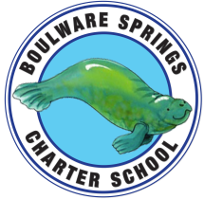
Boulware Springs Charter School
1303 NE 23rd Avenue, Gainesville, FL 32609 (352) 244-9732
kayabbitt@boulwarecharter.com

Board Meeting Agenda
Tuesday, November 12
5:30PM

- Call Meeting to order Dennis

- Discussion/Motion to approve minutes from Sept 17
Board meeting Dennis

- Board Approval of Changes to contract Kay

- Financials Kay
  - Financials and YTD through Sept 2019
  - Board approval of 2018-2019 audit

- Student/Teacher update for 2019-2020 Kay

- Updates Kay
- New Business Board

- Old Business Board

- Set next meeting date Board

- Adjourn Dennis

