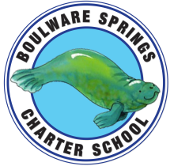
Boulware Springs Charter School
1303 NE 23rd Avenue, Gainesville, FL 32609 (352) 244-9732
kayabbitt@boulwarecharter.com

Board Meeting Agenda
Tuesday, May 28, 2019
5:30PM

- Call Meeting to order Bryan

- Discussion/Motion to approve minutes from April 9
Board meeting Bryan

- Discussion re: Board Member Terms/Chair Bryan

- Discussion/Board vote on Insurance 2019-2020
Year Bryan/Board

- PTO/Short Term Disability Proposal Kay

- Financials Kay

  - Financials and YTD through April
  - Approve budget for 2019-2020 school year

- Student/Teacher update for 2019-2020 Kay

- Kay Evaluation/Update on Goals Kay/Board
  - MAP Testing

- Kitchen Improvements Kay

- Report on Capital Outlay Expenses Kay

- New Business Board

- Old Business Board

- Set next meeting date Board

- Adjourn

