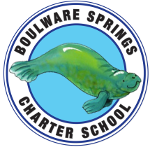
Boulware Springs Charter School
1303 NE 23rd Avenue, Gainesville, FL 32609 (352) 244-9732
kayabbitt@boulwarecharter.com

Board Meeting Agenda
Monday, October 22, 2018
5:30 PM

1 - Call Meeting to Order Bryan

2 - Discussion/Motion to approve minutes from last board meeting Board

3 - Update on financials Kay
- Year to date expenses
- Sept monthly report
- Audit
- IRS Form for 990
- Expenses over 3k

4 - School Safety update Kay
- Guardian program

5 - Bylaws update Kay/Board
- Vote on approval
- Conflict of Interest

6 - Survey 2 info Kay
- Student count
- ESE

7 - Gainesville Empowerment Zone Kay

8 - Personnel Kay

9 – New Business Bryan/Kay
- Evaluation for Kay by year’s end

10 – Old Business Bryan

11 – Upcoming Meeting Dates Bryan

12 – Adjourn Bryan

